Homework 4

Kyle Cahitas

2023-05-25

## Question- How does fish length predict fish weight for trout perch (across all sample years)

#filtering data, importing csv  
fish_df <- read_csv(here("data", "ntl6_v12.csv")) %>%   
   
 #filtering rows that have "TROUTPERCH  
 filter(spname == "TROUTPERCH") %>%   
   
 #selecting specific rows  
 select(spname,year4,length,weight) %>%   
   
 #renaming columnns   
 rename(year = year4)

1.Hypothesis

Linear models describes linear relationship between variable and predictor

Null Hypothesis: There is no significant relationship between trout-perch length (mm) and trout-perch weight (g), indicating that trout-perch length does not indicate trout-perch weight. There is no significant relationship between trout-perch length (mm) and trout perch weight (g), due to the slope of the regression line result to zero or the p-value was greater than 0.05.

Alternative Hypothesis: There is significant relationship between trout-perch length (mm) and trout-perch weight (g), indicating that trout-perch length can predict trout-perch weight. There is significant relationship between trout-perch length (mm) and trout-perch weight (g), due to the slope of the regression line resulting to not equal zero and having a p-value lower than 0.05.

# 200 missing rows for weight  
# have all rows for length   
gg_miss_var(fish_df)

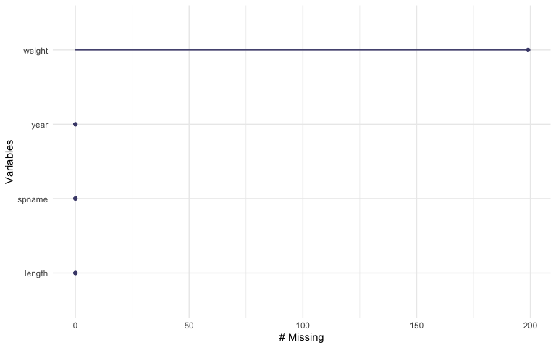

When running the function gg_miss_var, a total of 199 missing observation was discovered in the column of weight. This resulted in having the original data frame be 489 to the new data frame being 290. These missing observation help assign weight be the depending variable and length being the independent variable.

#using tidyverse to filter out any Na values in the weight column # and deleting that row in the process  
troutperch_Na <- fish_df %>%   
 drop_na(weight)  
  
#View(troutperch_Na)

#quick visual of the data   
ggplot(data = troutperch_Na, aes(x = length, y = weight)) +   
   
 geom_point()+  
   
 labs(title = "Trout-perch lengths and weight")+  
   
 theme_classic()

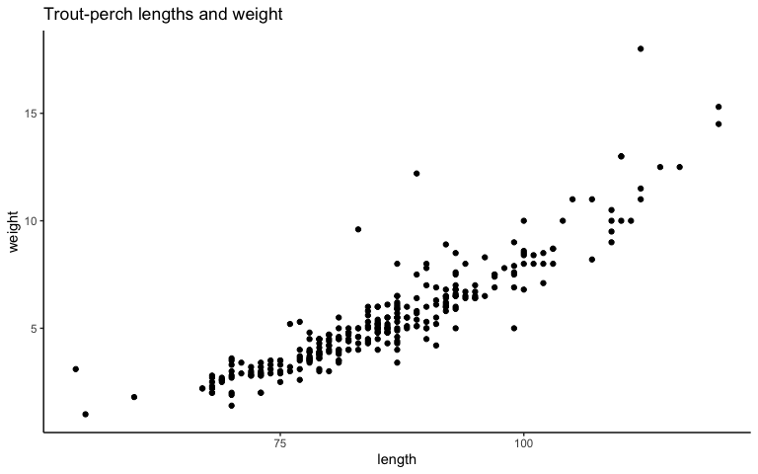

By looking at a quick visual of the data, there appears to be a somewhat postive slope, but more tests need to be done.

1. Diagnostic Plot

#diagnostic plot  
modelobject <- lm(weight ~ length, data = troutperch_Na)  
  
#combining all four groups in a 2 x 2  
par(mfrow = c(2,2))  
  
plot(modelobject)

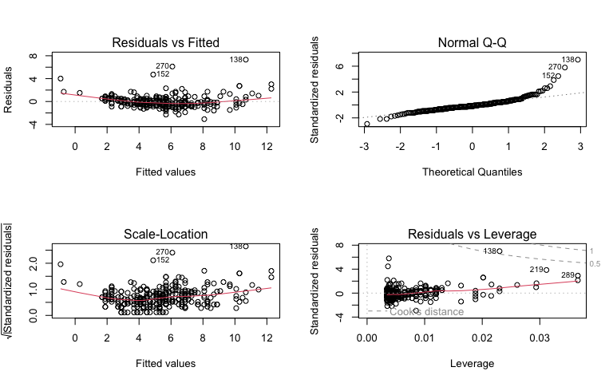

The diagnostic plot “Residual vs Fitted” visually implies that the data is heteroscedasticity. The observations are clumped in the middle and are not scattered.

The diagnostic plot “Normal Q-Q” visually implies that data is normal but the right tail is very close to not being normal.

The diagnostic plot “Scale-Location visually implies if the data is heteroscedasiticty or homoscedasticity. Again, majority of the data resides in the middle, concluding that the data is of heteroscedasiticity.

The diagnostic plot “Residual vs Leverage” visually implies if there any outlier within the data. There appears to be one data point that is outside of the dashed line and thus, a outlier.

1. Summary

#using function summary() to display results   
model_summary <- summary(modelobject)  
  
model_summary

Call:  
lm(formula = weight ~ length, data = troutperch_Na)  
  
Residuals:  
 Min 1Q Median 3Q Max   
-3.0828 -0.4862 -0.1830 0.4128 7.3191   
  
Coefficients:  
 Estimate Std. Error t value Pr(>|t|)   
(Intercept) -11.702476 0.481564 -24.30 <2e-16 ***  
length 0.199852 0.005584 35.79 <2e-16 ***  
---  
Signif. codes: 0 '***' 0.001 '**' 0.01 '*' 0.05 '.' 0.1 ' ' 1  
  
Residual standard error: 1.057 on 288 degrees of freedom  
Multiple R-squared: 0.8164, Adjusted R-squared: 0.8158   
F-statistic: 1281 on 1 and 288 DF, p-value: < 2.2e-16

The function summary

1. ANOVA

#anova is used to get analysis of variance tables for a model   
model_sqaures <- anova(modelobject)

#creating a table that demonstrates ANOVA  
model_squares_table <-tidy(model_sqaures) %>%   
 # round the sum of squares and mean squares columns to have 5 digits (could be less)  
 mutate(across(sumsq:meansq, ~ round(.x, digits = 5))) %>%   
 # round the F-statistic to have 1 digit  
 mutate(statistic = round(statistic, digits = 1)) %>%   
 # replace the very very very small p value with < 0.001  
   
 mutate(p.value = case_when(p.value <0.001 ~ "<0.001")) %>%   
   
 #creating a table   
 flextable() %>%   
   
 #changing the header, for ease of understanding   
 set_header_labels(df = "Degrees of Freedom",   
 sumsq = "Sum of squares",  
 meansq = "Mean squares",  
 statistic = "F-statistic",  
 p.value = "p-value"  
 )  
model_squares_table

| term | Degrees of Freedom | Sum of squares | Mean squares | F-statistic | p-value |
| --- | --- | --- | --- | --- | --- |
| length | 1 | 1,432.2877 | 1,432.28769 | 1,280.8 | <0.001 |
| Residuals | 288 | 322.0525 | 1.11824 |  |  |

8.In 1-2 sentences, describe how the ANOVA table relates to the information you get from the summary() object.

The ANOVA tables relates to the summary() object, in terms of finding if the slope is equal to zero or not equal to zero. By incorporating sum of squares and mean squares, the F-value if the value is large means that the variation among group means is more than expected by chance, and can conclude that the slope is not equal to zero.

9.In 2-3 sentences, summarize your results in prose with in-text references to test results. Include all relevant information.

When running the summary(), the t-value for length was 35.79, the length’s slope was 0.19985, p-value was <2e-16 and the standard error was 0.005585. When running the ANOVA the F-test was 1,280.8 and p-value was less than 0.001. The results from both tests, concluded that the length slope is postive, has a p-value lower than 0.05, thus we can reject the null hypothesis and accept the alternative hypothesis and can conclude that fish length can predict fish weight for trout perch.

1. Model Prediction Plot

predictions <- ggpredict(modelobject, terms = "length")  
  
View(predictions)

plot_predictions <- ggplot(data = troutperch_Na,   
 aes(x = length, y = weight)) +  
 #type of graph   
 geom_point() +  
 # plotting the predictions on data   
 geom_line(data = predictions,   
 aes(x = x, y = predicted),   
 color = "brown", linewidth = .9) +  
   
 # then plot the 95% confidence interval from ggpredict  
 geom_ribbon(data = predictions,   
 aes(x = x, y = predicted, ymin = conf.low, ymax = conf.high),   
 alpha = .2) +  
   
 ## theme and labels ##  
 theme_economist()+ #from ggthemes   
   
 # labeling plot   
 labs(x = "Length (mm)",  
 y = "Weight (g)",  
 title = "Prediction of Trout-Perch"  
 )+   
 #adjusting functions   
 theme(  
 plot.title = element_text(face = "bold"),  
 axis.ticks = element_line(linewidth = 3, color = "darkgray")  
 )  
   
plot_predictions

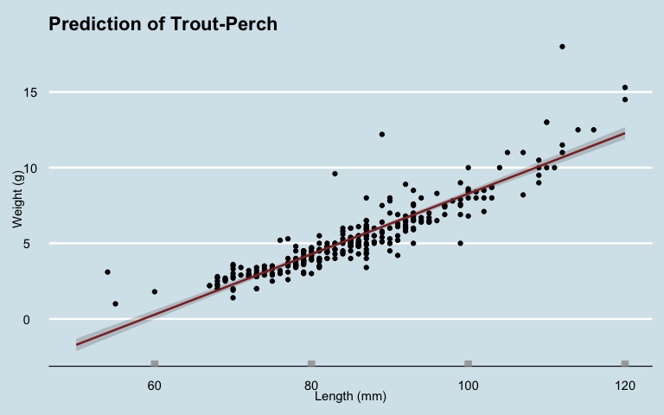

The above plot demonstrates data regarding the weight and length of trout perch in the North Temperate Lakes from 1981 to 2022. By conducing ANOVA and using the “summary()” function, we had significant evidence to reject the null hypothesis and accept the alternative hypothesis. This is viewed being that the slope of this plot does not equal to zero but the length of the trout perch exhibits a positive slop.

The brown line in the plot represents the prediction interval, which establishes a range of values where the response is likely to fall, given a specific length value. The gray shading surrounding the prediction interval signifies a confidence level of 95%, indicating the accuracy of the prediction interval. In conclusion, this data can be utilized to predict the weight of a trout perch based on its length in the North Temperate Lakes.